Assignment Creation in LMS Course

The assignment activity provides a space into which students can submit work for teachers to grade and give feedback on. This saves on paper and is more efficient than email. It can also be used to remind students of 'real-world' assignments they need to complete offline, such as art work, and thus not require any digital content.

Student submissions are together on one screen of your course. You can require them to submit one or several files and/or to type text essays. It is possible to have them submit work as a group and you can also choose as a teacher to grade their work 'blind' in other words not to see the identities of those who have submitted assignments. Assignments can have deadlines and cut off dates - which you can also extend if necessary.

Assignment Types:

Students can type directly into Moodle, upload files or add media. The options are in the Submission types section in Assignment settings page.

Online text: Text typed into the HTML editor is automatically saved and the teacher can set a Word limit which will display a warning if students exceed it.

File submissions: Students can upload files of any type the teacher specifies. The teacher can specify the maximum number of files which may be uploaded and a maximum size for each file.

Students may be able to add a note (comment) to their teacher when they submit their work.

- Login to LMS and open your course.
- Click on the “Turn Editing On” button.

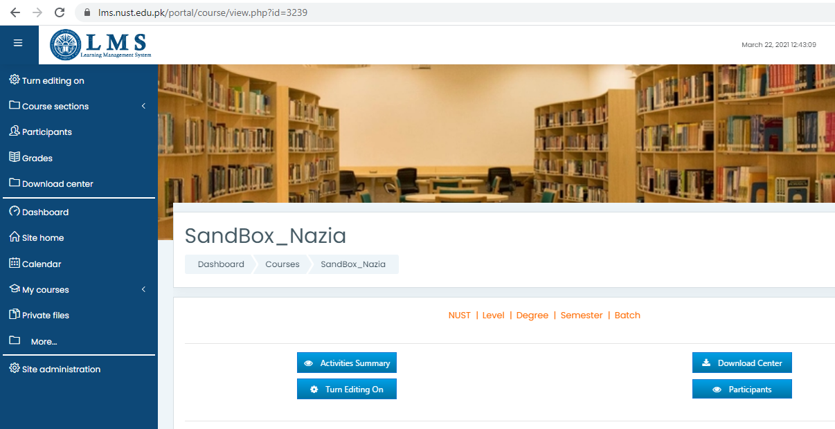

- Click 'Add an activity or resource” and choose 'Assignment' from the activity chooser.

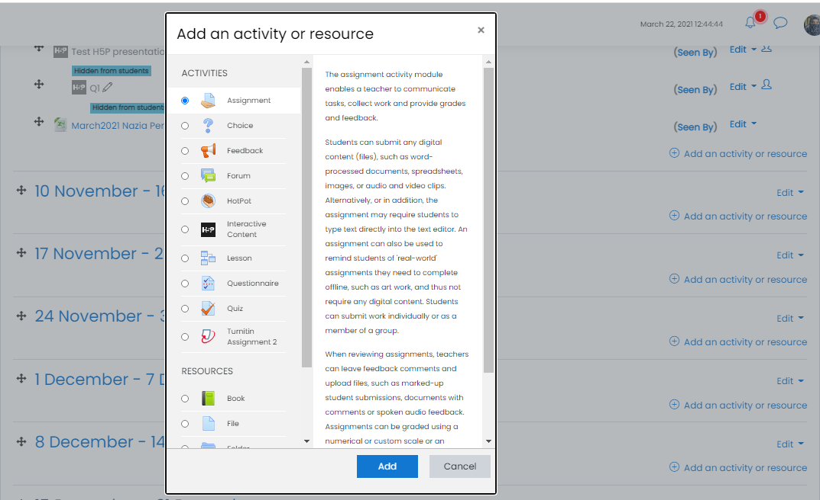

- Give a name to the assignment, in the description explain what the students must submit. You can upload a help or example document from the Additional files area.

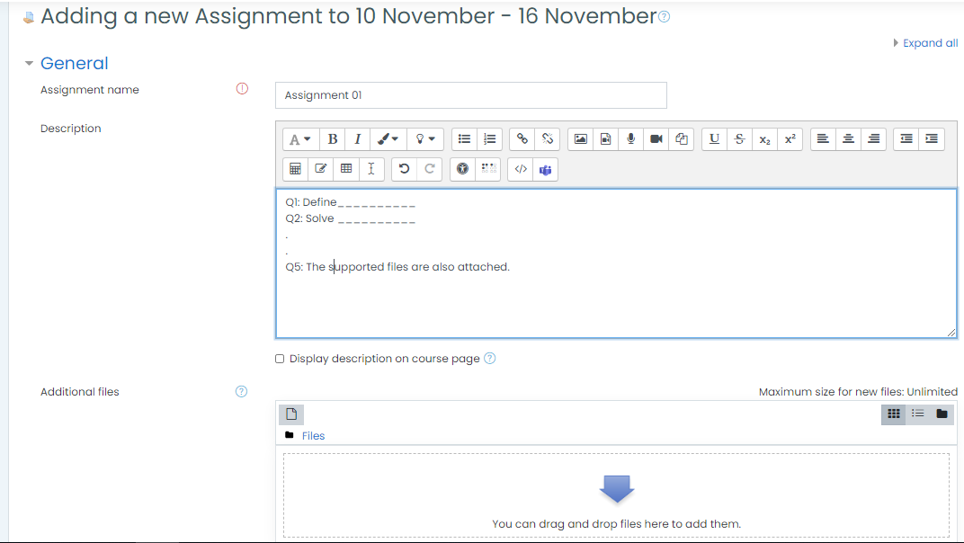

- Availability
  - Allow submissions from
This stops students from submitting before the shown date but it doesn't hide the assignment and any included instructions or materials.
  - Due date
Submissions are still allowed after this date but will be marked as late. Disable it by unchecking the checkbox. Assignments without a due date will appear on the dashboard with 'No Due Date' displayed.
  - Cut-off date
After this date, students will not be able to submit and the submit button will disappear.
  - Remind me to grade by
A date needs to be entered here in order for the assignment to display on the teacher's Course overview block and in the Calendar. It will display when at least one student has submitted.

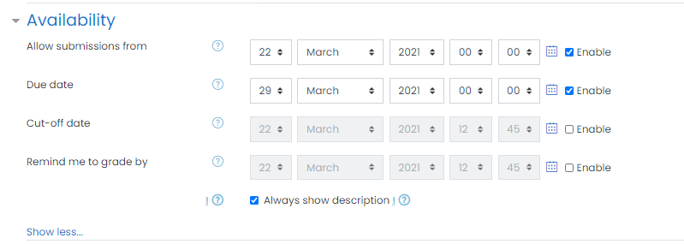

- Submission types
Here you can decide how you wish students to submit their work to you.
  - Online text
Students type their responses directly in Moodle using a text editor. It's possible to set a word limit on an online text assignment. Students get a warning if they try to exceed the word limit.
  - File submissions
Students can upload one or more files of any type the teacher can open. The teacher can annotate uploaded PDFs, docx and odt files within the browser, and on saving, the annotated file is made available to the student.
  - Maximum submission size
The maximum upload size refers to each file a student uploads. It cannot be larger than the limit in the Course settings.
  - Accepted file types
The teacher can specify the types of file the students may upload to the assignment.

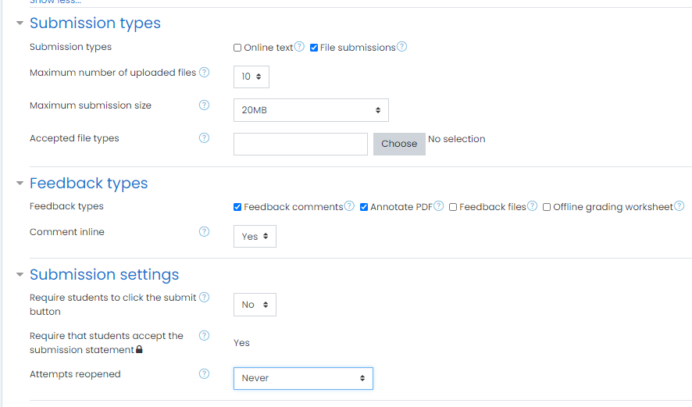

- Submission types
  - Feedback comments
With this enabled, teachers can leave comments for each submission (which will appear on the assignment grading screen.)
  - Annotate PDF
It will allow the teacher to annotate using comments, stamps and other features.
  - Feedback files
This allows markers to upload files with feedback when marking. These files may be the marked up student assignments, documents with comments, a completed marking guide, or spoken audio feedback.
  - Offline grading worksheet
This is useful if you wish to download the grading list and edit it in a program such as MS Excel. When the teacher has completed their grading offline, they can then upload the spreadsheet
  - Comment inline
This usefully allows you to comment directly on an 'online text' type submission.

- Submission Settings
  - Require students click submit button
If this is set to 'No' students can make changes to their submission at any time. (If you want to stop them changing work once you are ready to grade, click 'View/Grade all submissions'; locate the student and From the Edit column, click the action icon and select 'Prevent submission changes.'
If set to 'Yes', students can upload draft versions of the assignment until such time as they are ready to submit. Clicking the submit button tells the teacher they have finished drafting and want the work to be graded. They can no longer edit it and must ask the teacher to revert to draft status if they need to change it again. To do that, click 'View/Grade all submissions; locate the student and from the Edit column, click the action icon and select 'Revert the submission to draft'.
  - Require that students accept the Submission statement
LMS defines a "Submission statement" i.e. a statement where students promise the work is their own and which they must agree to before submitting their work. A student will see the statement when accessing their assignment.
  - Attempts reopened
You can change this here to 'Manually' and reopen it for students to resubmit.

- Groups submission settings
  - These settings allow students to collaborate on a single assignment, eg, working in the same online area or uploading, editing and re-uploading an MS Power point in the common assignment area.
  - When grading, the teacher may choose to give a common grade and feedback to all students in the group or to give individual grades and feedback to each member.

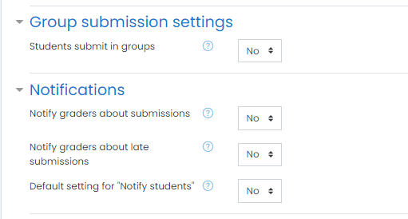

- Grade
  - When grading an activity it is possible to use a grading scale, a grade point (numerical scale) or neither. Max grades are set by the teacher.
  - Setting a passing grade may be connected with Activity completion and Restrict access such that a student will not be able to access a follow up activity until they have passed this assignment.
  - The teacher can choose either 'Simple direct grading' or any advanced grading methods plugins. Selecting 'Simple direct grading' means that the advanced grading is not used and the standard grade selector is displayed.
  - Enable Marking Workflow if you need to keep grades and feedback hidden until you are ready to release them (otherwise by default they display to each student as you save them).

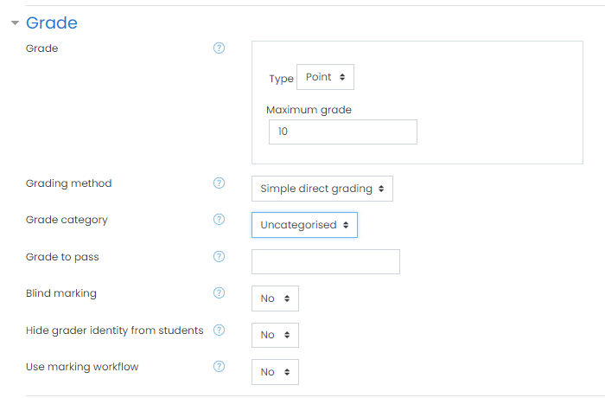

- Common Module Settings
  - Availability:
If the availability is set to “Show on course page”, the activity or resource is available to students (subject to any access restrictions which may be set). If the availability is set to “Hide from students”, the activity or resource is only available to the users with permission to view hidden activities (by default, users with the role of teacher or non-editing teacher)
  - Group mode This setting has 3 options:
(1) No groups
(2) Separate groups - Each group member can only see their own group activity, others are completely invisible
(3) Visible groups - Each group member works in their own group activities, but can also see other group activities as well.
  - Grouping
Select the respective grouping from the dropdown.

  - You need to explicitly click the button “Add group/ grouping access restriction” to enable the selected grouping.

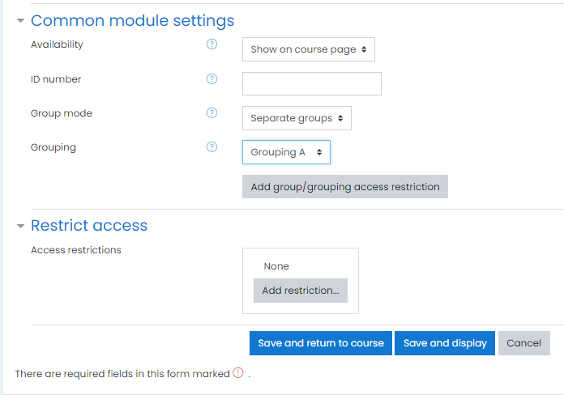

  - Clicking the button will display the applied restriction in the next section of “Restrict access” settings

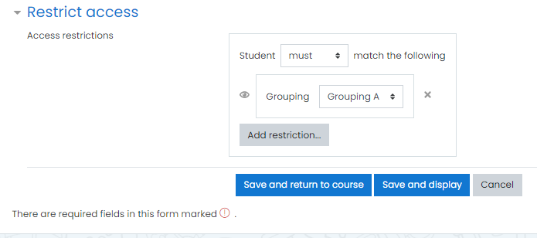

- Restrict Access
  - Additional restrictions can be applied if required

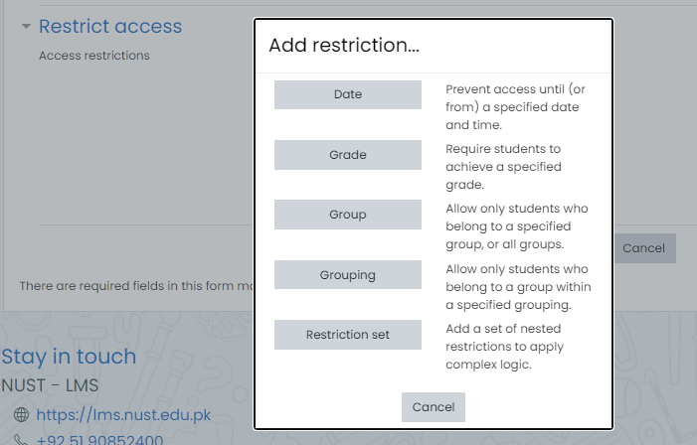

- The access restrictions can be verified after saving the assignment and returning to the courses page.

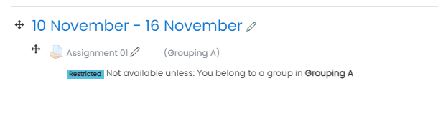

Download/ Grade the Assignments:

- You can view the submissions stats by clicking on assignment link. The page will show the complete details about the assignment contents, due date, the total number of participants, the submitted assignments etc.

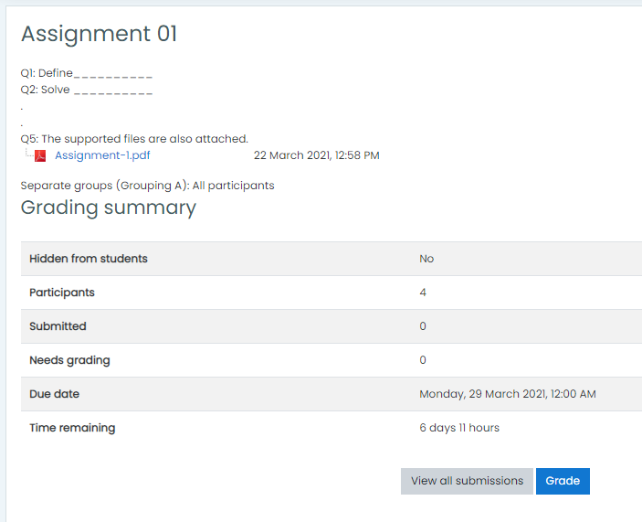

- Click on the “View all submissions” button to have access of all submitted assignments, which can be viewed, downloaded, given feedback and graded.

- You can choose to display the list of all participants of a course or can choose to display, grade, download their submissions or can choose a particular group.

- After updating the grades of students, click on the “Save all quick grading changes” button.

- You can choose to inform the students about the grading completion.

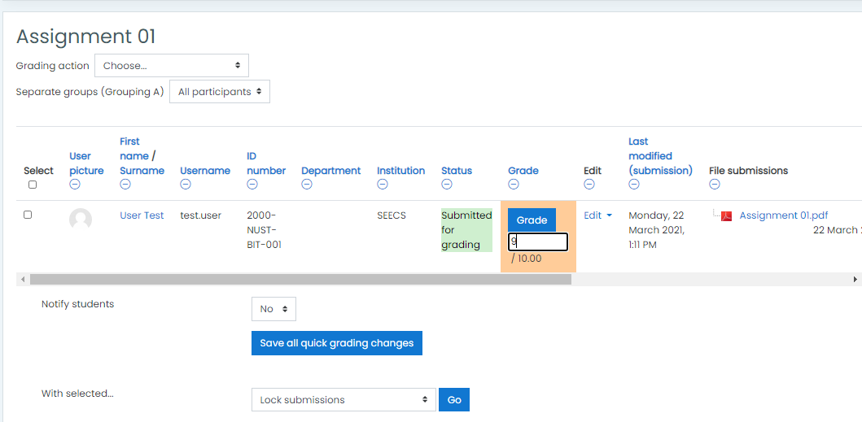

- In order to download the assignments, check the checkbox in title row checkbox to select all users.

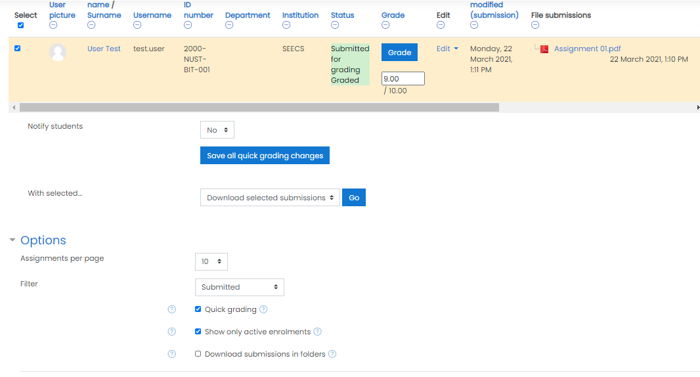
- Choose the action you want to perform with the selected users and click on the “Go” button.

- If you have given single file upload option to the students, you can choose to un-check the option “Download submissions in folder”. This will download all submissions in a single folder and will append students’ names in their submission file names.

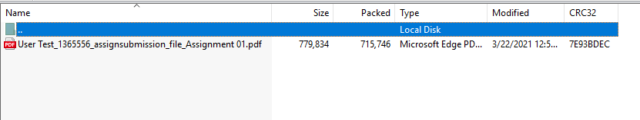

However, if you have allowed students to submit the “Multiple files”, you may choose to download the students’ submission in separate folders by selecting the option “Download submissions in folders”.

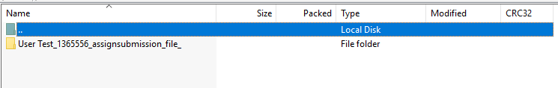

Student View:
Students click the assignment link and click “Add submission”

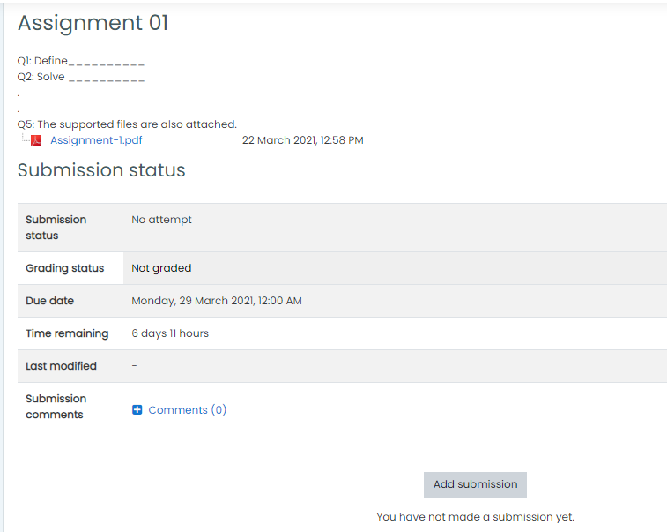

- Depending on the assignment settings, they either have a text box into which to type their work or an upload area to submit their file.

- The students need to explicitly accept the “submission statement” before uploading their submissions.

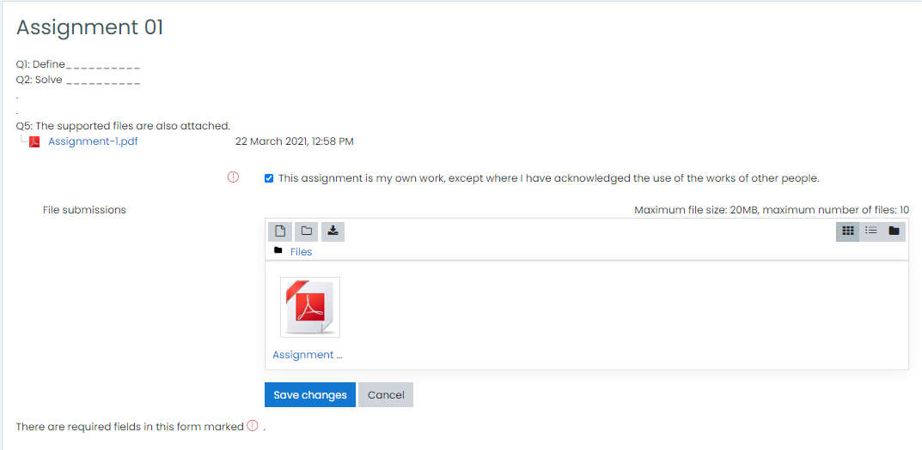

- They may be able to return to their work and redraft it, or they might have to click a submit button to send in a final version which cannot be changed.

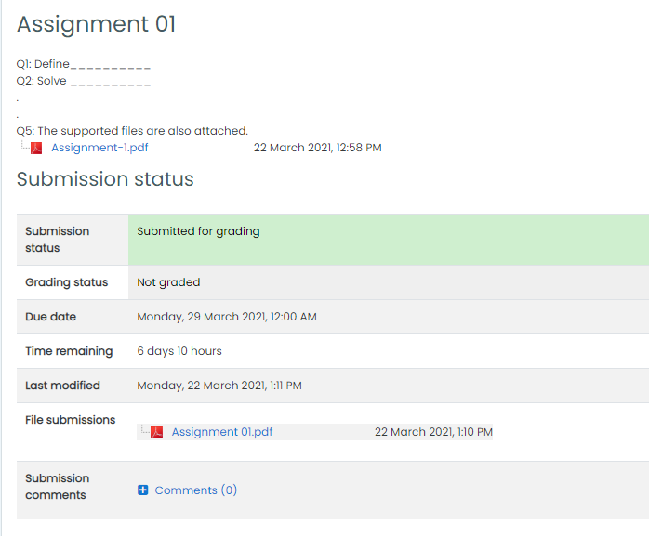
- Once the teacher has graded the assignment, student can view the attained marks and teacher’s feedback after clicking on the assigning link.





